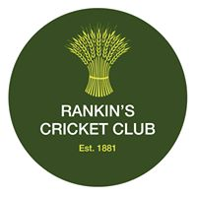

Rankin’s Cricket Club 100 Club

JOIN OUR 100 CLUB TODAY AND YOU COULD BE OUR NEXT WINNER!

Dear Members

So, who wants the chance to win £300.00?

As a community cricket club we are always looking at ways to raise funds to enhance and improve our facilities and grounds; and a great way of doing this is for our members to join our ‘100 Club’!

How does it work, I hear you say? Members buy a ‘share’ that costs £5.00 each. That share (or shares, as you can purchase as many as you’d like) are then entered into a draw which takes place four times a year, at the monthly committee meetings in March, June, September and December.

How much can I win? Every draw….

One lucky member wins, first prize - £300.00

Three lucky members then win, second prize - £100.00 (each)

And finally, six lucky members win third prize - £50.00 (each)

Winners will be published on the club website rankins.hitscricket.com or contacted directly by Martin Shields.

To enter, please set up a standing order for £5.00 (per share) a month, payable on the 1st of each month, using your name and ‘100’ as the reference, to the club’s bank details as follows:

Rankins Cricket Club – account number 70589993 – sort code 20-79-73

Once you have signed up, please contact Martin Shields mfshields@hotmail.co.uk (07917 374137) who will deal with the formalities. Martin will also be able to answer any questions you may have.

What are you waiting for?

Rankin’s Cricket Club
Broomhills, Stambridge Road, Rochford, Essex SS4 2AF

